Auditor: Mason Atkin Audit: Parks Fiscal Management 09/16/2024

C-01-009
Meeting Purpose
Meeting Participants
- Interviewee:
Chris Silkie, Manager Asset Management
Claudio Campuzano, Finance, Property & Technology Manager – Audit liaison (did not attend)
- Audit Team: Mason Atkin (interviewer and notetaking)
Conclusion
See highlights for important information.
Cross-references
Interview Questions
- What do you see as the biggest challenge or area of improvement for Parks in terms of the deferred maintenance gap?
It’s accumulated to be so much that it is beyond the current organizational capacity to manage. In terms of risk that’s accumulated to employees and the public, and also financially. Lets say someone wrote us a check for $600M dollars today, we would still see failures and see those adverse impacts. And it will be a decade until we have recovered. It’s almost like you could say the deferred maintenance gap is the biggest challenge.
B
A
We must prioritize major maintenance, the funding of it. It’s been clear that’s not the highest priority for the city. City waived the capital set aside policy multiple times. That policy says that any forecasted surplus – half must be spent on deferred maintenance for parks and pbot. Through a vote of council they have waived that policy themselves. Impacts PBOT as well as parks. Usually both Parks and PBOT come away with the lions share of capital set aside when it occurs. So when it doesn’t happen both bureaus feel it.
If you look at capital asset reports on deferred maintenance they go back to 2006, those have been presented to council, there have been work sessions. It’s been the same story. We could get a check for $600M tomorrow, and assets would still close. (Auditor notes: presumably because just getting money isn’t enough to actually initiate and staff projects.)
- Can you provide some background on how you Parks got into the structural deficit (operating, capital maintenance, capital growth)? (probe beyond an explanation of the technical gaps between revenue and spending to why those were allowed to be created in the first place.) How will Parks prevent it from happening again?
Chris has been with Parks 8 years. It became clear to Chris there was a large accumulated gap and estimate. Looking at the numbers, the average age of buildings is over 65 years old and most major buildings need major rehabilitation every 30 years. A major investment cycle didn’t happen. The background is historical inadequate investment levels.
On the positive side starting the asset management program is a good thing – Chris was the first manager for that. It’s little dollars instead of big dollars, but it’s a start.
There’s an associated gap in operational maintenance – think the levy has helped with that as well. We have more electricians, plumbers, people to clean gutters on the roof. Helps prevent things failing faster than they should. Doesn’t mean don’t need replacements but prevents deceleration of decay.
Don’t need to speculate politically. Knowledge is a big part of it. The former director, Mike Kobacky(?), he was proud when Chris first started – we have Some amount of money (Chris says possibly $2 or $4M?) for major maintenance each year. Chris remembers being shocked with what an inadequate amount that is for a system of this size. Now a lot of people recognize it requires much more investment.
- How is 1 in 5 assets failing in the next 15 years calculated? Is it another way of stating that there is $600 in deferred maintenance?
It’s kind of related to the $600M deferred maintenance.

The 1 in 5 assets – we’ve gone back and forth on the wording of it. It shouldn’t be 1 in 5 will fail. It is an estimate that hinges on your definition of failure. The way 1 in 5 came about – is we looked at instances of closures where we had to close something because an unsafe condition had gotten so bad. Looked at that over the total asset base at the current investment level, and the condition that things are in. And we know how long different assets take to decay. We know that 1 in 5 are going to be at the extreme end of poor condition in the next 15 years. It could be worse than that.

I want to add that there is off the shelf software that calculates this for roads and other assets, but for Parks there isn’t. We built the model ourselves. Someone on my team is good at the data on things. Programmed in some factors. Made a scenario to see how much money spent in next 10 years could impact the condition. It answers how much do I need to spend to have a good condition portfolio.
A
The $600M estimate - I try to be careful, the real number could be $800M or $550M.

It’s an estimate based on the given investment level of what we’ve had to close in the past, and the rate that decay will happen at the current investment rate.

Chris shares a dashboard on his screen (See screenshot 1)

Screenshot 1: Projected outcome if Parks receives $750M in investment 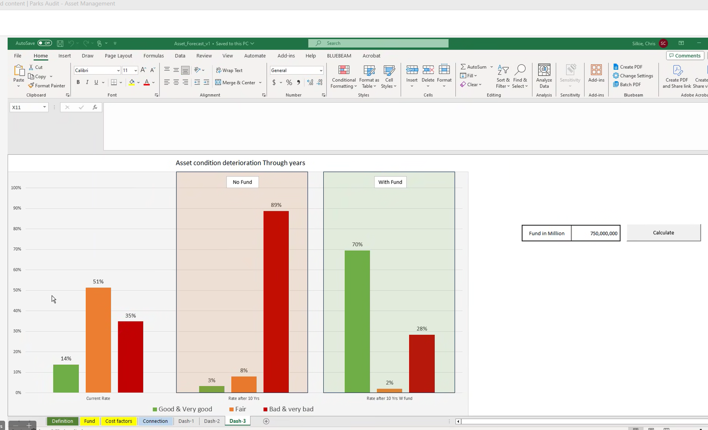
B
A
Green is good, orange is poor, red is very bad. No fund is no funding in 10 years, and then if we fund to $750M what the condition could be. Some red is perfectly normal for organizations. Some should be headed that direction so we always have something to work on.

Screenshot 2: Projected outcome if Parks receives $1B in investment

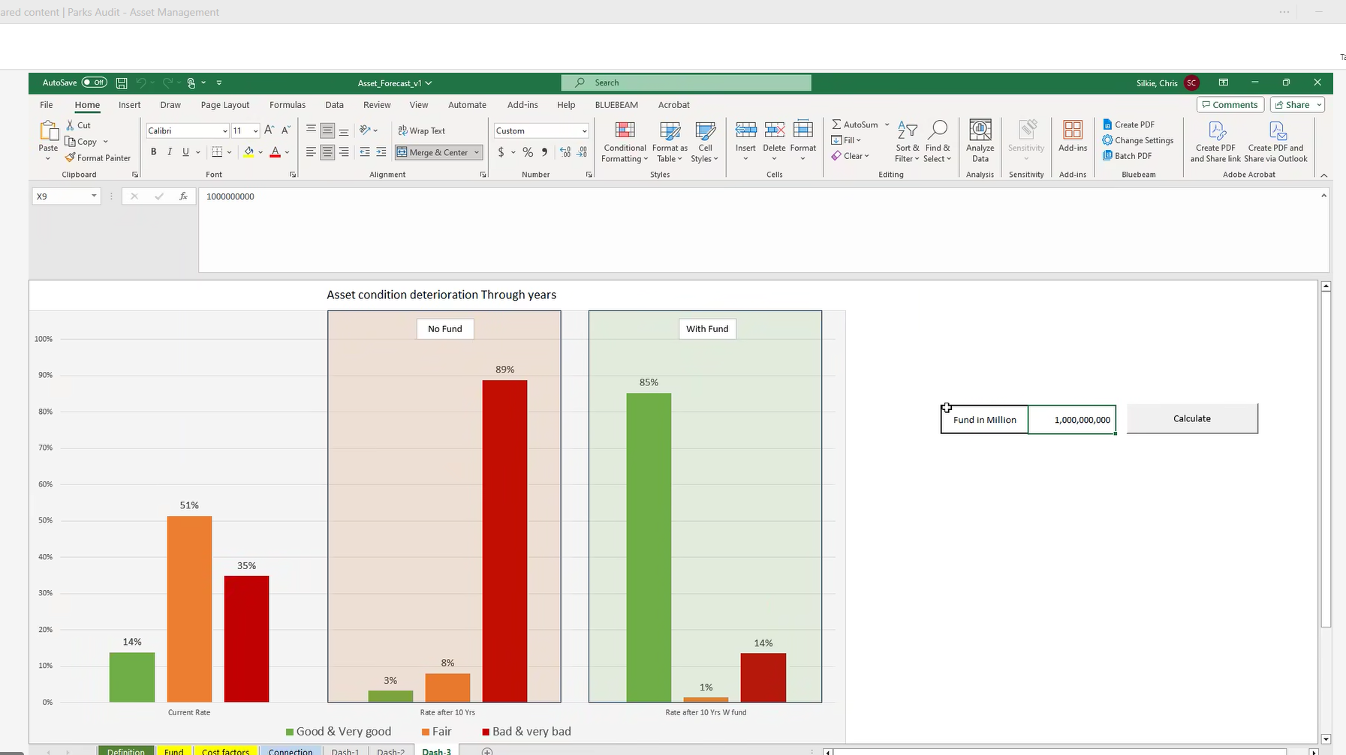

Funding a billion looks really healthy. It’s based on the degradation of each asset, and then applying money based on our policy. This is just an excel nothing that fancy.

Screenshot 3: the data tab that shows asset condition ratings (column H) and replacement cost (column G)

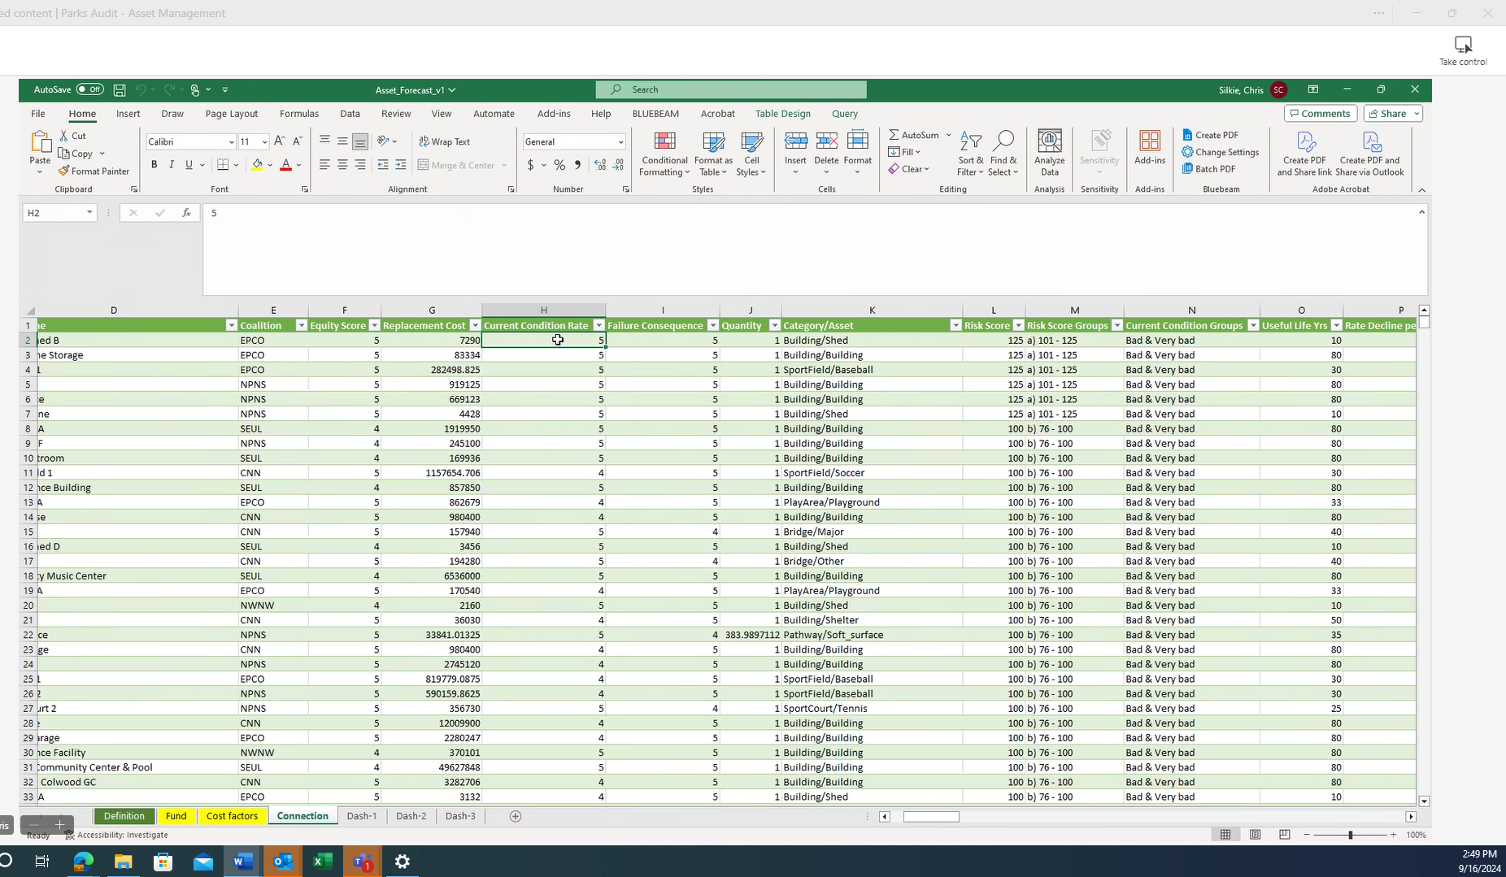

Parks policy states that worse condition gets funding first. So here (screenshot 3) if something has a condition rating of 5, then assumed it would need to be funded in full at that year mark.

- Which assets will fail and how was that or will that be decided?

As it stands right now at current funding levels, it’s going to be the ones that aren’t prioritized. The capital major maintenance criteria from the capital major maintenance annual approval process is the first step. Apply that criteria to the 1000s of things on the list. That’s how the conversation starts.

Example: a couple years ago went through major maintenance process. Had a Charles community center HVAC system that needed replacement for a couple million bucks. And the sellwood pool needed a filter to be replaced, for like $1.5M. We only enough funding to do one. Asked the recreation service director to make the call on which one. Decided to do Charles community center because it operates year round, operates meals on wheels, offers programing for youth and seniors. The pool is seasonal and is not as important to the community. The Charles Jordan project is happening right now. And sellwood pool is at risk of failure by next summer. May be able to scramble together money for a bottom line boiler by next summer, but 50% chance it could close.

Is there anyway to see these things coming?
I think the issue is the list of all the items is too overwhelming. There are thousands of things. It gets seen when it gets down to picking between two things. In my opinion that is a good practice to elevate those either/or’s of very specific things to leadership, having leadership choose A or B. Good to have those decisions at highest level of organization. Increases the pressure to make those decisions.

Robin manages the emergency maintenance process. The monthly meeting for emergency maintenance is where it’s discussed that, okay this playground actually failed and if we want to repopen the playground we need $50,000 tomorrow. Every year we run out of money for emergency funding.

It would be nice if we could share that decision making burden, because right now it’s happening at engineering level or manager level. For the annual process that I run, director Long is the decision maker and we’re all advisors.

Another example, is when the 2014 replacement bond team had to decide about Columbia pool. There wasn’t enough money for fixing both matt dishman center and Columbia pool. The bond program had to make the decision on which to fund. And look where we are with Columbia pool today. It’s almost like measuring the decision that wasn’t made. From my perspective there are hundreds of those out there, big things that could be closed, deemed unsafe or shut down. That could happen at any time due to other factors – not receiving funding over time, environmental conditions, or the randomness of how good the construction quality was originally. All these other factors.

Doing their best to triage the downward spiral. Either a resource level change or portfolio level change. You can’t change physics.

How do you square the idea of expanding the portfolio for equity reasons when the deferred maintenance gap is so large?

If there’s no playground somewhere, there is zero value to the community. And if there’s something degraded and operating at less value, but greater than zero. That’s how I square it, is that it’s risk tolerance.

From a financial perspective, that’s a different story.

Maybe it’s not the either/or issue of maintain this existing park or build a new park. Maybe both should be funded and a third thing should have funding reduced. Auditor asked if he meant funding should be reduced within the City generally or within Parks. Within in the city as a whole, or possibly just Parks. Would need community involvement to decide what investments are important to them. I will add that we have shed many of the assets that we could. The smaller community centers like Sellwood community center and hillside community center, a few buildings here and there that weren’t costing a lot of service, we’ve been able to get rid of those. We’ve done mostly what we could. The low hanging fruit we’ve already picked. Other things there may be controversy which makes it harder, like if the community is going to have an uproar.

The city doesn’t follow it’s own policy. It’s not followed or enforced. The one time cost of a new asset is pretty small, it’s like 10% of the whole amount. Like if a playground is $1M then it actually is $10M over time with O&M. And it’s easy for the city council to say I approve the $1M and then not worry about the $10M. You feel the tradeoff in 10 years. The policy is only 10 years old.
A

- What can keep assets from failing?

There’s tactics. Been talking of high level structural things. Tactics you can do include designing the most maintainable, durable lowest lifecycle cost design when build something. You can standardize things. Budget for maintenance like plumbers, utility workers. That makes a big difference. It’s going to degrade over time but be a shallower curve.

An example of that is our preventative maintenance key performance indicator should be a lot higher. The measure measures how much time has passed and are all the preventative maintenance tasks being completed. Such as every quarter we change filters. We should be doing a hundred percent of the preventative maintenance and we aren’t even close to that. The deferred maintenance impacts operational maintenance in addition to capital maintenance.

An analogy is when the housing crisis happened with the bad mortgages. We have an asset base that we can’t afford. Or a car, buying a big SUV and really I should be riding my bike.

- What will happen when they fail?
  - What money will be used to pay for dismantling them?
  - What will happen if there isn’t money for dismantling?

Hopefully we find out about it before something bad happens. There’s a lot of risk out there.
An example: montavilla picnic shelter was discovered through routine building assessment. Engineering tech saw the shelter and saw it was leaning. It was an unreinforced masonry building. Tech said that thing is unsafe, you gotta put a fence around it and keep people from getting close to it. Which means you have to demolish it. Then there are engineer costs to hire a consultant, the fencing costs – have to rent the fences – and a demolishing cost. And that is to remove the service that is being provided but hasn’t been maintained. That picnic shelter is gone. The last straw is fencing, detailed specialist evaluation and a closure decision. Columbia pool went through the same thing. Some out there that we may not catch, risk of injury or worse. Risk of environmental damage. If the decision was to fix it and not demolish it, it will be 5x or 6x more expensive if would have been handled in a preventative way. And that end of life stuff is funded by the emergency maintenance budget.

What are cases where you wouldn’t be able to see it coming?
We do pretty good now that we have a full assessment program. It’s not getting everywhere all the time, try to assess things every 5 years with a checklist. That should catch most things. There’s some known looming risks out there. We own some natural gas pipeline under waterfront park. Any underground utilities are quite old. Most are water so the failure will be a sewage spill or a flood in the park. Try to focus on the scary failure modes like the structural failure or electrical which is where people can get really hurt.

An example – we got lucky. A baseball stadium by Westmoreland. A big transformer that was ours, just fell and shattered on the pavement. Lucky no one was there. But then we have to call someone out and look at the other transformers. That same level of effort done years ago could have prevented that near miss. The big transformer was not part of the assessment program. I don’t think that we would have caught it, it’s kind of a specialty thing. But there should have been some kind of evaluation.

Screenshot 4: fallen transformer picture shared
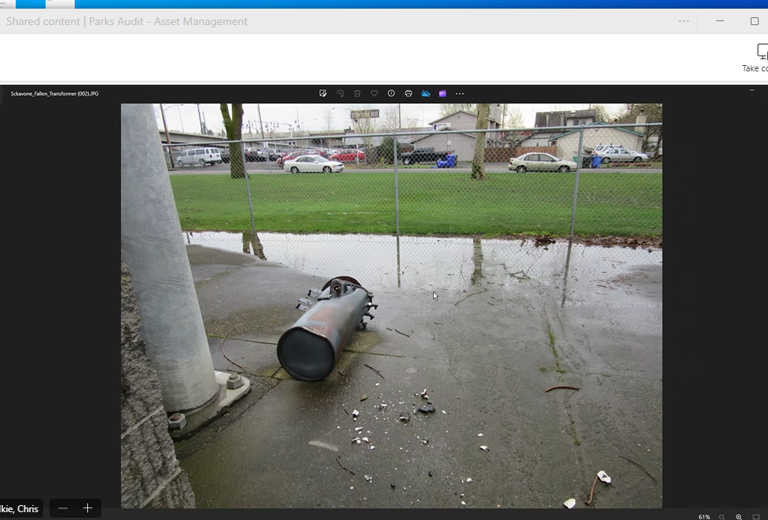

Our risk safety officer – Vanessa. Might know of actual examples where people had gotten hurt.

